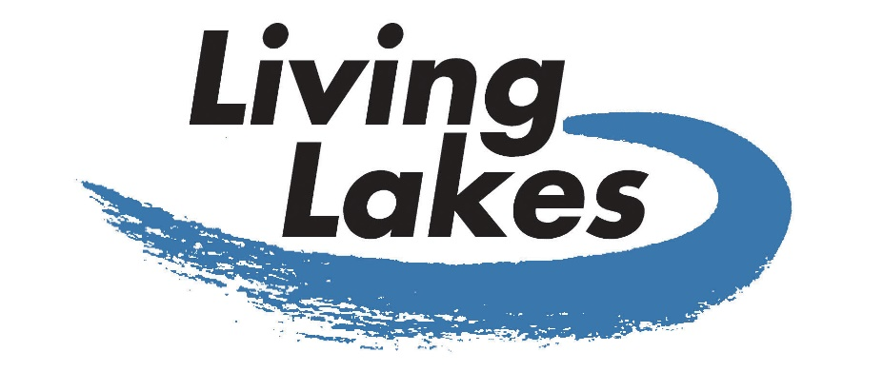

Membership Criteria & Application Form for
Living Lakes Network
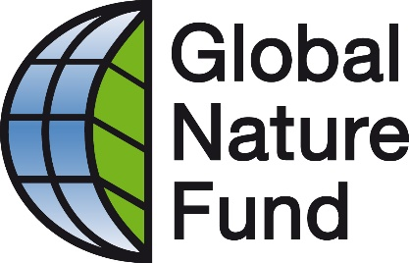
Global Nature Fund
Fritz-Reichle-Ring 4
D-78315 Radolfzell, Germany
Tel.: +49 7732 9995-80
Fax: +49 7732 9995-88
info@globalnature.org
www.globalnature.org

Content

I. Mission, Vision, Terms of Reference 3
Mission 3
Vision 3
Objectives 3
Terms of Reference for membership in the Living Lakes Network 3
II. Procedure and Criteria for membership in the Living Lakes Network 4
Four step procedure for the approval of new Living Lakes members 4
At least one of the following criteria has to be met by the respective lake or wetland area 4
The following criteria have to be met by the applying organisation 4
III. Annual Membership Fee 5
IV. Application Form for Living Lakes Membership 6
1. Applicant 6
2. Geographical specifications 8
3. Origin 9
4. Physical information 9
5. Ecological features 9
6. Nature conservation and problems 12
7. Additional Information Resources 13
8. Explain how your organisation and the lake meet the criteria of the Living Lakes partnership 14
9. Describe your expectations of being a Living Lakes member 14
10. How do you see your contribution to the Living Lakes Network? 14
11. Enclosures 14

Revised: June 2019
- Mission, Vision, Terms of Reference

Mission
Living Lakes is an international network and partnership whose mission is to enhance the protection and restoration of lakes, wetlands, other freshwater bodies of the world and their catchment areas.

Vision
All lakes, wetlands and freshwater bodies of the world should be healthy ecosystems and where they are used by humans, that use should be sustainable and not damaging to the ecosystem.

Objectives
- To conserve the biodiversity, ecological integrity and the preservation of lakes, wetland ecosystems and their watersheds.
- To restore altered and disappearing wetlands and lake ecosystems.
- To improve the quality of life for the local communities living around lake and wetland ecosystems (Agenda 21).
- To build commitment towards sustainable use and development of these ecosystems for agriculture, fishery, tourism, settlement, energy and water.
- To promote the use of applied sciences and technologies towards the conservation of these ecosystems.
- To support educational programmes and cooperation with local communities and all stakeholders or users focusing on the conservation of the biodiversity of these ecosystems.
- To disseminate information relevant to these ecosystems.

Terms of Reference for membership in the Living Lakes Network
Members:
- Declare their agreement with the Living Lakes’ Mission and Vision.
- Participate in the Living Lakes Conferences and other events and activities.
- Produce an annual progress report on relevant activities in their area.
- Seek active co-operation with other Living Lakes partners.
- Support Global Nature Fund in the development of the Living Lakes website, participate in working groups and contribute to publications (brochures, newsletters etc.) where appropriate.
- Contribute to the successful achievement of the Living Lakes Mission and Vision.
- Encourage exchange programmes for volunteers, staff and other stakeholders within the Living Lakes Network.
- Support and promote environmental education for the better understanding of lake and wetland areas.
- Procedure and Criteria for membership in the Living Lakes Network

Four step procedure for the approval of new Living Lakes members

- Applications have to be filled in by an authorised person and sent to the GNF headquarters. By applying for membership you agree to the Mission, Vision and Terms of Reference of Living Lakes.
- GNF will review the application and request additional information where appropriate. The application will be presented to the GNF Board. After all possible questions and queries have been cleared up the board will release the application for the next step of the application procedure.
- GNF will send the application via e-mail to all Living Lakes members. If there are no objections by a given deadline, the application is accepted. If there is an objection, further discussions must follow.
- The GNF Board makes the final decision regarding the admission of the applicant as a member of the international Living Lakes Network. The applicant will be informed about the decision.

At least one of the following criteria has to be met by the respective lake or wetland area

- The lake or wetland is ecologically important and
- hosts endemic or endangered species,
- is of international importance,
- is a gathering place for migratory birds.
- The lake is threatened by human use.
- Land development plans threaten the lake.
- Legal regulations are not respected.
- The lake is not legally protected or needs better legal protection.
- In the lake area there are examples of nature conservation practices.

The following criteria have to be met by the applying organisation

- The organisation preferably is of a non-profit, non-governmental organisation (other organisations such as national park authorities, scientific institutes etc. need to have an NGO as a co-partner);
- The organisation is active in the management of / conservation of / environmental education at specific lakes, wetlands, rivers, or water bodies and their catchment area;
- The organisation demonstrates interest and commitment contributing to the development of the Living Lakes Network;
- The reliability of the network partners is an indispensable requirement for admission. The applying organisation is committed to fulfil the conditions of the Mission, Vision and Terms of Reference of Living Lakes.
- In case, there are three or more partner lakes in one country it is recommended to create a national Living Lakes Network.

- Annual Membership Fee

The Annual Membership Fee in the Living Lakes Network is 200 EUR per member organisation. Member organisations that cannot afford a membership fee, have the possibility of applying to waive it – but not for longer than two consecutive years.

- Application Form for Living Lakes Membership

Name of the Lake: _______________________

Please note for joint applications: If more than one organisation is applying please answer the questions 1.a) - 1.p) separately for all co-applicants.

1. Applicant
- Name of organisation applying for membership:

- Address of organisation
Postal address:
Contact person:
Phone:
E-mail:
Website:

- Legal status (foundation, association etc.). Please enclose statutes or charter or other appropriate document as well as proof of non-profit status, if possible in English.

- Number of (payed) staff members
Total:
Those involved in lake activities:

- Number of members and/ or volunteers supporting the organisation
Total:
Those involved in lake activities:

- Founding year of organisation:

- When did your organisation begin carrying out conservation work in the lake area:

- Budget for current fiscal year:

- Sources of funding (e.g. private donations, public grants, business sponsors etc.):

- Does your organisation cooperate with
- corporations or businesses? Please describe and name business sponsors.

- municipal, provincial, federal governments? Please describe.

- Overall mission and goals of the organisation (for goals specifically concerning the lake see next question):

- Your organisation’s goals concerning the sustainable development and conservation of the lake:

- List activities, projects and programmes that your organisation has carried out in the lake area during the last three years. (Please enclose information materials if appropriate)

- What activities, projects and programmes regarding the lake is your organisation planning for the future?

- Budget planned for the next three years to implement activities, projects and programmes for the lake:

- Description of your organisation for presentation on GNF website (approximately 200 words):

- Description of the lake area for presentation on GNF website (approximately 200 words):

2. Geographical specifications

- Name of the lake/wetland:

- Country/countries in which the lake is located:

- District (region):

- Size of the lake in square kilometres:

- Catchment area in square kilometres:

- Maximum depth of the lake in meters:

- Sea level in meters:

- Description of the inlet and outlet of the water body:

- Access to the water body (i.e. road, boat, train):

3. Origin
Please explain the geological formation of the water body (i.e. ice age, tectonics):

4. Physical information

- Precipitation per year in millimetres:

- Salinity:

5. Ecological features

- Total number plant species:
- Number of endemic species

- Number of endangered / threatened / rare species

Examples of plant species: | English term: | Scientific term: | Number: | Category (endemic, registered in Red Data Book, globally rare, etc)
… for more plants please use separate sheet

- Total number of animal species :
- Number of endemic species

- Number of endangered / threatened / rare species

Examples of animal species | English term | Scientific term | Number | Category (endemic, registered in Red Data Book, globally rare, etc)
… for more species please use separate sheet

- Species of migratory animals using the area as resting place:
Animal species | English term | Scientific term | Number
e.g.: birds | California Gull | Larus californicus | 50.000
… for more species please use separate sheet

- For breeding species
Animal species | English term | Scientific term | Number of breeding couples
e.g.: birds | California Gull | Larus californicus | 50.000
… for more breeding animal species please use separate sheet

- Riparian vegetation:
 | Yes | No | Comments
Forest
Tundra
Semi-Arid
Desert
Pasture
Grass
Field (farmland)
Others

- Human (demographic) environment in the lake area
- Number of people living around the lake (in the lake catchment area)

- Population density

- Average income of the local people

- Existing planning processes applied in watershed (i.e. Lake Management Plan, Official Community Plan, etc.). Please include the date of adoption, and a link to the document if possible.

- Please indicate kinds of settlements (i.e. small indigenous communities or big cities etc.) (max. 100 words)

6. Nature conservation and problems

- Protective status
 | Yes | No | Comments
UNESCO World Heritage
UNESCO Biosphere Reserve
RAMSAR Convention
IBA – Important Bird Area
Natura 2000 (EU)
National Park
Regional Nature Reserve
Other:

- Level of the anthropogenic concerns
 | None | Low | Medium | High | Comments
Water withdrawal
Pollution by pesticides
Industrial waste water inputs
Salinity levels
Over-fishing
Hunting
Settlement
Tourism
Damming/Diking
Intensive farming near the shore
Shoreline development
Lack of regulation enforcement
Invasive animal species
Invasive plant species
Aquaculture
Other

- Please describe the environmental problems and challenges in the lake area (max. 200 words)

- Raising awareness, disseminating information
 | Yes | No | Description
Local information centre
Other

7. Additional Information Resources
Most important publications (not more than 5 titles) concerning the lake, its landscape, people, plants and animals.
Authors | Year | Title | Publisher

8. Explain how your organisation and the lake meet the criteria of the Living Lakes partnership

Please provide arguments using comparisons with other lakes within your country

(Max. 400 words)

9. Describe your expectations of being a Living Lakes member
(Max. 200 words)

10. How do you see your contribution to the Living Lakes Network?
(Max. 200 words)

11. Enclosures
Publications of Applicant (newsletters, annual reports, leaflets, etc.)
Title | Kind of publication | Year

